**INDIAN AGRICULTURAL CROP PRODUCTION ANALYSIS**

TEAM MEMBERS  
 M.Kaviya  
 A.Lathikasaran  
 M.Malarkodi  
 V.Nadhiya  
INTRODUCTION

1.1. **Overview**:

According to The World Bank, India is a global agricultural powerhouse. It is the world's largest producer of milk, pulses, and spices, and has the world's largest cattle herd (buffaloes), as well as the largest area under wheat, rice and cotton.

1.2. **Purpose:**

Protect and enhance the environment and natural resources. Protect the economic viability of farming operations. Provide sufficient financial reward to the farmer to enable continued production and contribute to the well-being of the community. Produce sufficient high-quality and safe food.

2. PROBLEM STATEMENT & DESIGN THINKING

2.1 **Empathy Map**

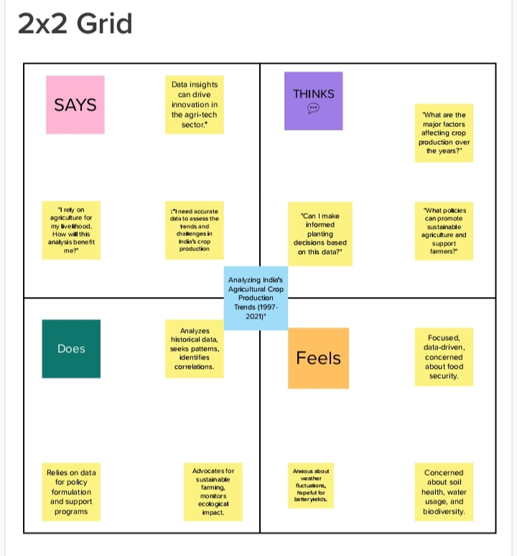

2.2. **Ideation and Brainstorming Map:**

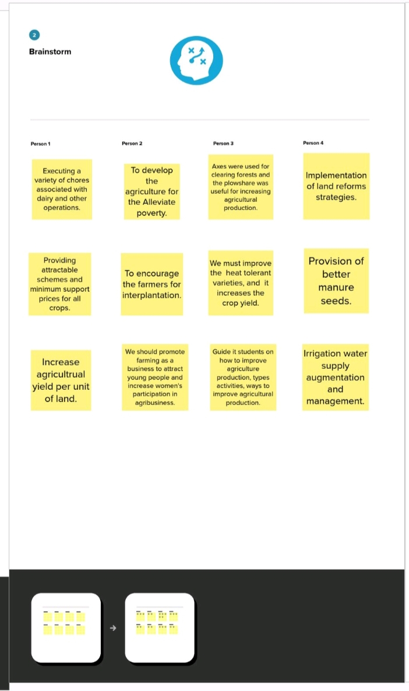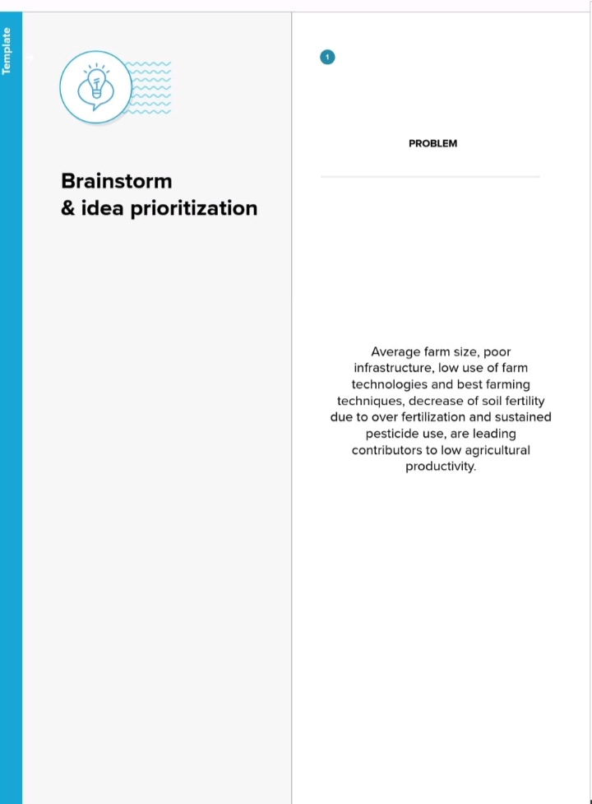

3. **work sheet :**

Students will understand and analyze the current events and issues that are occurring in agriculture and how they affect your future in agriculture. Students will be able to recognize and examine the relationships between inputs and outputs in their agricultural field to make effective and profitable decisions.

4. **Dashboard**

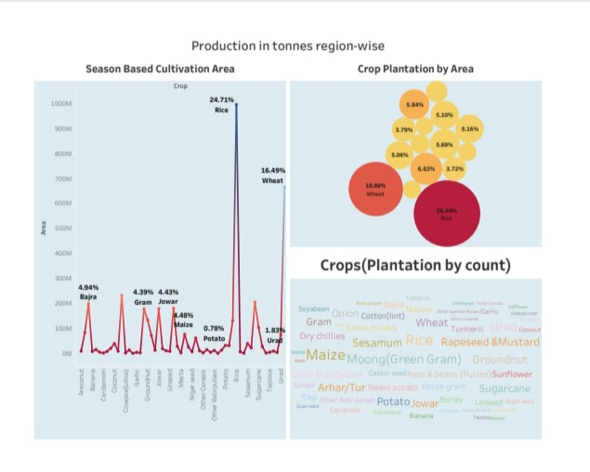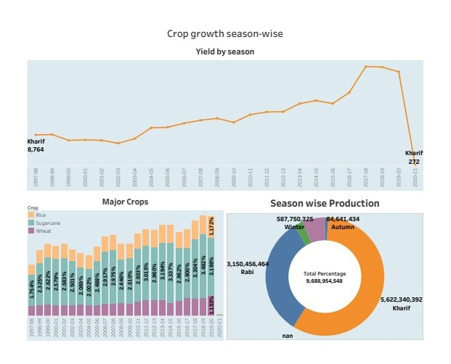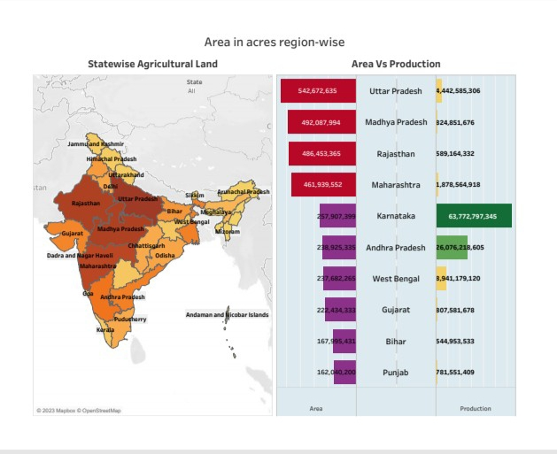

5..story line :  
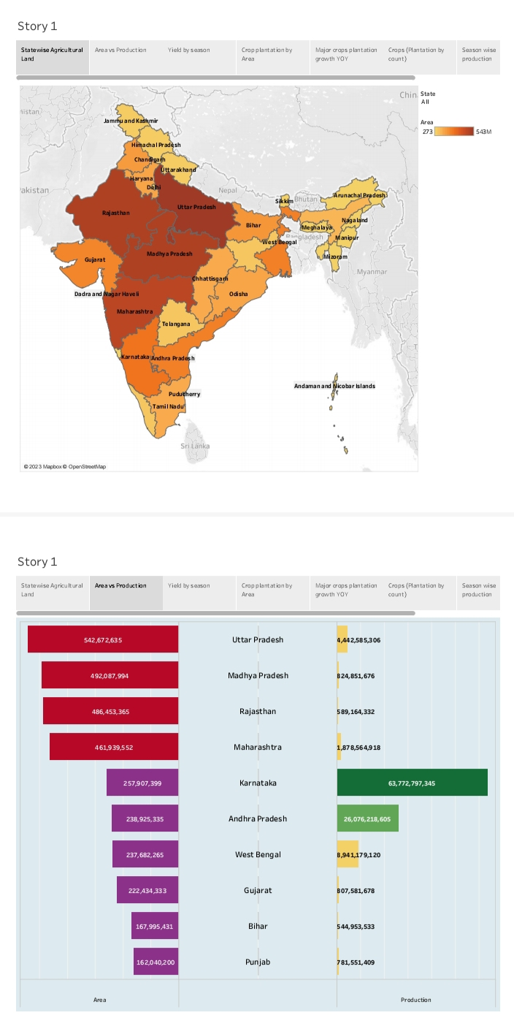  
  
  
6. **Advantages & Disadvantages**

Increase in physical production is the most common benefit of agricultural projects. The irrigation projects lead to increased yield through controlled water supply.

 Intensive agriculture can lead to soil erosion, deforestation, water pollution, and loss of biodiversity. Depletion of natural resources: Agriculture can lead to the depletion of natural resources such as water and soil, and can lead to land degradation and desertification.

7.\***Applications**

Through sustainable agricultural practices, farmers and ranchers help ensure the profitability of their land while improving soil fertility, helping promote sound environmental practices, and minimizing environmental impacts through climate action.

8. **Conclusion**

The study concluded that education is important to the improvement of agricultural productivity such that formal education opens the mind of the farmer to knowledge, non- formal education gives the farmer hands- on training and better methods of farming and informal education keeps the farmer abreast with changing

9. **Future Scope**

Increasing population, increasing average income and globalisation effects in India will increase demand for quantity, quality and nutritious food, and variety of food. Therefore, pressure on decreasing available cultivable land to produce more quantity, variety and quality of food will keep on increasing